Wurks f'me tha knows!

It's Grim Up North!
Relocating in Northern England is good for business; lots of the starving unemployed eager to work for a pittance of pay and daring not to complain or they'll be out on the street with their dozens of screaming bairns, and their benefits cut for six months.
• But are you really getting the most from them?
• Are they 'as much use as a chocolate teapot' when it comes to the complexities of modern technology?
Research has shown that Northerners aren't as thick as they make out. They just can't grasp the meaning of modern English.
That's why you need our new software package . . .
Word for Northerners!
The installation process automatically modifies their Windows start button
All the usual Word menu option are there, but in a language your Northern England employees can understand
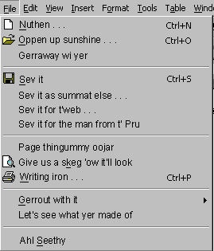

Even the warning messages have changed
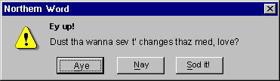
And if all else fails, they will have a help facility that folks from Barnsley and Bradford can understand
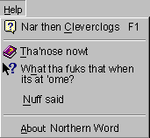
So what are you waiting for? Me to go to the foot of our stair?!
Buy your employees Northern Word today, and see your profits rise!
For this month only we'll ship Northern Word to you for the incredibly daft price of
Only £59.99 +VAT !
Tha'd 'ave t'be soft in t'head not to say "Aye, champion!"
And that's not all!
Respond to this advert within 10 days and receive free:
Great New Translating Tool!
With this little beauty you can have your employees type in their own language:
Ow do youth, 'ows tha bin?
A mun tell thee that t'clever sods 'ere at Hardwick and Granville 'ave cum oop wi this reet grand gubbins wot can 'elp thee a treet.
Its sorta like this great whopping oojah wi' flashing lights an' knobs on an' all wot can do thee addin up faster than thar can spit on a whippet. An' that's saying summat!
If tha wants a skeg then get thee arse over t' Wool Exchange on Mundy where wil be showing t'bugga off.
If thars a jammy sod then 'appen thar'l even win a prize, so who sez tha dunt get owt for nowt in this world?!
Ah'll sithee then youth,
John Northerner
Bloke wot does t'marketing
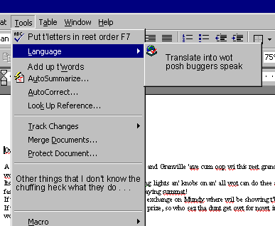
At a touch of a key Northern Word can convert it into proper English.

Et Voilà!
Dear Mr Customer,
Announcing the new Accounts software from H&G Systems Ltd!
Come along to our stand at the NEC this Monday and see it for yourself!
Enter your business card into the lucky draw for a chance to win a great prize!
Hope to see you there,
John Southerner
Marketing Executive

With this piece of clever software your customers need never even know that you are exploiting a demoralised workforce of ex-miners and ex-shipyard welders desperate to work for your pitiful barely legal wages!
And you'll make a killing!
For further details, e-mail northernword@patronisingmanagers.com
Testimonial
But don't just take our word for it.
Here are some of the great things people have been sayimg about Northern Word:
"Before we installed Northern Word onto the PC's of all our journalists, no-one outside of the West Riding of Yorkshire would buy our paper. Now even Saath Landoners can understand it!" Editor, Telegraph & Argus
"Thank you for creating such an excellent product! Now my employees can use Northern Word to write out their CV's, as I am making them all redundant next week!" Manager, Bastard & Greedy Ltd
"Phew, what a God-send! Now I can dismiss all the monkeys working in our typing pool, and employ Northerners instead at a much cheaper rate!" N.Other Manager, Screwthepoor & Sons
"Is't tha tekking piss or summat? Ah'll come ovar there and give thee such a clout that <cut>" Fred Hardwhaite, Northerner
Don't delay!
Buy Northern Word Today!

